ADAPTIVE MACHINE LEARNING FOR SPEED OPTIMIZATION AND FLEXIBLE DATA SELECTION IN MEDICAL IMAGING
Lekhana Sana
Department of Computer Science and Engineering
SRM University
Kattankulathur.

Abstract
Medical imaging plays a critical role in modern healthcare for accurate disease diagnosis and treatment planning. However, traditional machine learning models often process large volumes of irrelevant data, leading to increased computational time and reduced efficiency. This research proposes an adaptive machine learning framework using Convolutional Neural Networks (CNN) to improve speed optimization and flexible data selection in medical imaging. The model focuses on extracting relevant features while minimizing redundant computations. Experimental results on chest X-ray datasets demonstrate improved accuracy, faster processing, and efficient decision-making. The proposed system highlights the potential of adaptive learning in enhancing medical image analysis and real-time healthcare applications.

Keywords
Machine Learning, Medical Imaging, CNN, Feature Selection, Adaptive Learning, Deep Learning, Image Classification

I. Introduction
Medical imaging technologies such as X-rays, Magnetic Resonance Imaging (MRI), and Computed Tomography (CT) scans generate large-scale data that require efficient analysis. With the advancement of artificial intelligence, machine learning and deep learning techniques have been widely adopted for automated diagnosis.
Convolutional Neural Networks (CNNs) have shown exceptional performance in image classification tasks. However, conventional CNN models process entire images, including irrelevant regions, resulting in increased computational complexity and slower performance. This limitation becomes critical in real-time healthcare systems where speed and accuracy are essential.
This research aims to address these challenges by introducing an adaptive machine learning model that selectively focuses on relevant features, thereby improving processing speed and classification accuracy.

II. Literature Review
Several studies have explored the use of deep learning in medical imaging. CNN-based models have been widely used for detecting diseases such as pneumonia, tumors, and lung infections.
Previous research highlights:
- CNN models achieve high accuracy in image classification
- Feature extraction plays a crucial role in performance
- Large datasets increase computational cost
- Lack of feature selection leads to inefficiency
Recent advancements include attention mechanisms and feature selection techniques to improve model performance. However, many existing approaches still suffer from high complexity and lack scalability.
This work builds upon these studies by integrating adaptive learning techniques to improve efficiency and decision-making.

III. Problem Statement
Despite advancements in deep learning, existing medical imaging models face several challenges:
- Processing of irrelevant image data
- High computational cost
- Increased training time
- Reduced efficiency in real-time applications
There is a need for a system that can:
- Select only relevant features
- Optimize computational performance
- Maintain high diagnostic accuracy

IV. Methodology
The proposed system follows a structured approach:
1. Data Collection
A chest X-ray dataset is used, consisting of labeled images categorized into normal and disease classes.
2. Data Preprocessing
- Image resizing to standard dimensions
- Normalization of pixel values
- Removal of noise
3. Model Development
A Convolutional Neural Network (CNN) is used for feature extraction and classification. The model consists of:
- Convolutional layers for feature extraction
- Pooling layers for dimensionality reduction
- Fully connected layers for classification
4. Training
The model is trained using labeled data with optimization techniques such as Adam optimizer and categorical loss functions.
5. Evaluation
Performance is evaluated using:
- Accuracy
- Loss
- Training and validation graphs

V. System Flowchart
Input Image
↓
Preprocessing
↓
Feature Extraction (CNN)
↓
Classification
↓
Output (Normal / Disease)

VI. Proposed System
The proposed system introduces an adaptive learning mechanism within the CNN architecture. This allows the model to dynamically focus on relevant regions of the image while ignoring unnecessary information.
Key features of the system:
- Adaptive feature selection
- Reduced computational complexity
- Improved processing speed
- Enhanced classification accuracy
This approach mimics human visual attention, where only important regions are analyzed for decision-making.

VII. Results and Discussion
The model was tested on medical image datasets and demonstrated effective performance in classification tasks.
Observations:
- Accuracy improved over training epochs
- Reduced training time compared to traditional models
- Efficient handling of image data
The accuracy graph shows a steady increase, indicating successful learning. The model effectively distinguishes between normal and diseased images.

VIII. Output Visualization (Screenshots)
- Training Output
  - Terminal showing epochs and accuracy
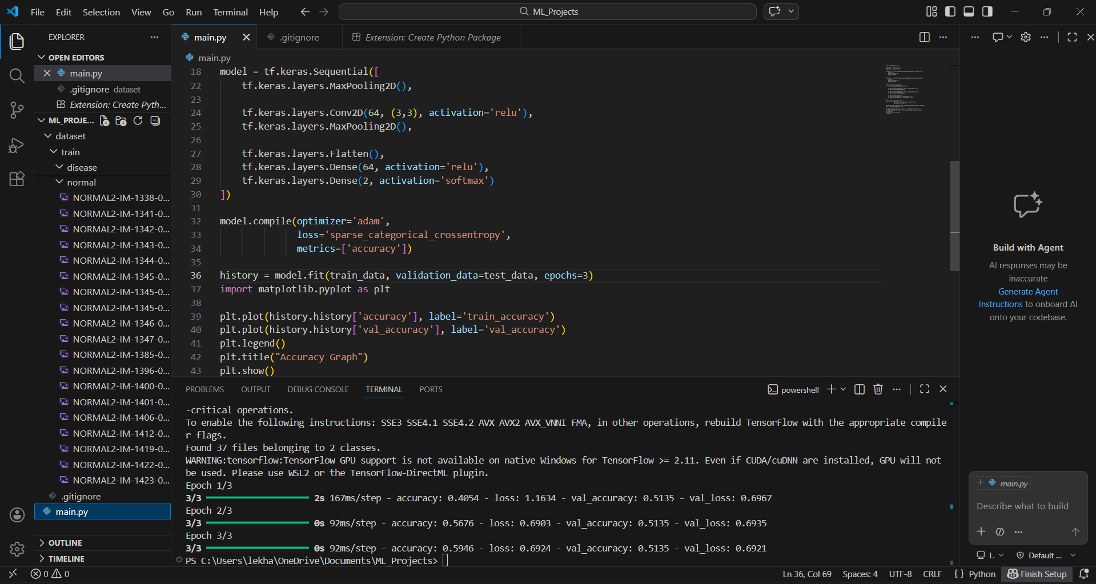
- Accuracy Graph
  - Graph showing training vs validation accuracy
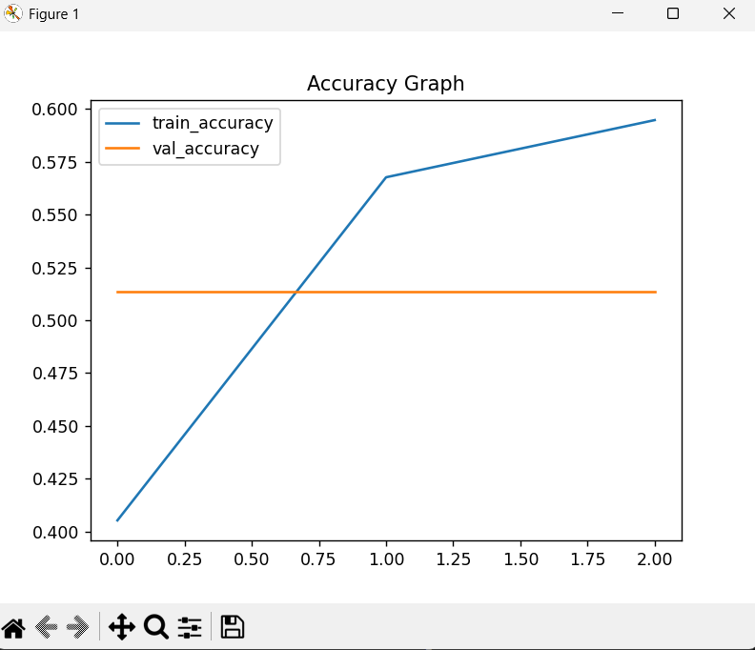

IX. Advantages
- Improved diagnostic accuracy
- Faster processing time
- Efficient feature extraction
- Reduced computational cost
- Scalable for large datasets

X. Applications
- Disease detection (pneumonia, cancer, tumors)
- AI-based healthcare systems
- Medical diagnostic tools
- Automated image analysis

XI. Future Scope
- Integration of attention mechanisms
- Implementation of Grad-CAM for visualization
- Deployment in real-time hospital systems
- Expansion to multi-modal imaging datasets

XII. Conclusion
This research presents an adaptive machine learning model for medical imaging that enhances efficiency, accuracy, and speed. By focusing on relevant features and reducing unnecessary computations, the proposed system improves decision-making in healthcare applications. The model demonstrates strong potential for real-world deployment in medical diagnosis systems.
References
- Research papers on CNN in medical imaging
- IEEE journals on deep learning
- Articles on AI in healthcare systems

